Complexity Computational Environments (CCE) Architecture
Geoffrey Fox, Harshawardhan Gadgil, Shrideep Pallickara, and Marlon Pierce
Community Grids Lab
Indiana University

John Rundle
University of California, Davis

Andrea Donnellan, Jay Parker, Robert Granat, Greg Lyzenga
NASA Jet Propulsion Laboratory

Dennis McLeod and Anne Chen
University of Southern California

Introduction
This document outlines the Complexity Computational Environment (CCE) architectural approach and is closely connected to the “Coupling Methodologies” paper [Parker2004]. We briefly summarize the material and conclusions in the first section of the paper, but we will not duplicate the extensive discussions there. The Coupling Methodologies document should be read in conjunction with the current document.

The remainder of this architectural document is devoted to a discussion of general approaches and solutions to the requirements identified in [Parker2004] and through team meetings. The general requirements and a summary of solutions are shown in Table 1.

Review: CCE Coupling Scenarios and Requirements
The Coupling Methodologies document focuses on the requirements for CCE applications. In brief summary, we investigate the central theme of the CCE project: mapping of the distributed computing coupling technologies (services for managing distributed geophysical applications and data) to problems in datamining/pattern informatics and multiscale geophysical simulation.

The following is an outline of the coupling paper’s major topics.
- Data requirements for applications, including database/data file access as well as streaming data.
- Service coupling scenarios: composing meta-applications out of several distributed components.
- Limits and appropriate time-scales for this approach.
- CCE data sources and characterizations (type of data, type of access).
- Pattern informatics techniques
- Multiscale modeling techniques
- Coupling scenarios that may be explored by the CCE project

Within CCE applications, we will adopt the “loose” or “lightly” coupling approach that is suitable for distributed applications that require millisecond (or perhaps much longer) communication latencies.

Tightly coupled communication is out of scope for the CCE. We will instead adopt (if appropriate) existing technologies for this. Prominent projects include the DOE’s Common Component Architecture (CCA) and NASA’s Earth Systems Modeling Framework (ESMF). These are complements, not competitors to our approach. In the lightly coupled CCE, applications built from these technologies are service nodes that may be coupled with data nodes and other services.
.
One prominent research project for supporting tightly coupled applications is the Grid Coupling Framework (or GCF) that was not covered in [Parker2004].

CCE Requirements and Solutions
The following table summarizes the CCE architecture requirements and approaches that we will follow in building this system. Sections that expand on these solutions are identified.

Requirement | Description | CCE Solution or Approach
Maximize interoperability with world. | Allow for easy adoption and integration of third party solutions: service instances and service frameworks, client tools, etc. | Adopt Web Service and Portal standards using the WS-I+ approach. See “Managing Web WS-<any> Specification Glut.”
Minimize lifecycle costs | Keep the cost of maintenance and training needed to keep the system running following the end of the project. | Adopt standard implementations of third party tools for Web services and portals where available and appropriate.
Security:  Protect computing resources. | Computing centers have account creation and allocation policies that we cannot change. We must support their required access policies | Support as needed SSH, Kerberos, GSI security. Leverage community portal efforts through NMI, DOE Portals and similar. See “Security Requirements.”
Security:  Protect community data | Need a authorization model for controlling access to data sources | In short term, implement solutions using portal authorization model. Investigate authorization solutions from Web Service community; integrate with NaradaBrokering framework. See “Security Requirments.”
Map multiscale models into workflow and metadata support. | Modeling applications must be described with metadata to identify where they fit in | CIE approach will be used to maintain metadata. Workflow will be mapped to scripting techniques (HPSearch). See “Core CCE Infrastructure: Context and Information Environment” and “Controller Environments for CCE: Portals and Scripting.”
Storage requirements | CCE tools will need three types: volatile scratch, active, and archival storage. | Hardware resources necessary to run CCE applications will be obtained from NASA JPL, Goddard, and Ames. CCE architectures will be compatible with these. We estimate mass storage requirements (terabytes).
Data source requirements. | Must support current community data sources for GPS, Fault, and Seismic data | Adopt standards (such as OGC standards for geospatial data) where they are available. See [Parker2004].
Computational requirements | The system must support computational | We will leverage NASA computational resources. The CCE system will be compatible with these sites.
Visualization requirements | The CCE must support earth surface modeling of both input data sources and computational results. Analysis techniques will use IDL and Matlab tools wrapped as services. | We will adapt OGC tools such as the Web Map Server to provide interactive maps with data sources and computational results as overlays. See “Visualization Requirements” for more information. Services to support wrapped IDL and Matlab will be developed.
Data modeling and query requirement | Must support standard models wherever they exist; must support schema resolution and meta-queries to resolve differing data models. | We will develop and integrate ontology management tools. See “CCE Data Models and Tools.”
Network Requirements | The CCE must take into account available network speeds required to connect | We will design the CCE to scale to a potentially Global deployment in cooperation with ACES partners. As described in [Parker2004] we will adjust the network dependence of our services to be compatible with standard internet latencies.  Higher performance for some interactive visualizations and data transfers may be required. Our approach to this is detailed in “Core CCE Infrastructure: Internet-on-Internet (IOI).”
Scalability | The system as a whole should scale to include international partners. | Fault tolerance, redundancy, and service discovery/management are critical if the system is to work on the international scale. We describe our approaches to these problems in the IOI and CIE sections of this report.

Table 1: CCE system requirements and solution approaches.

In the following section we review applications and scenarios that we are pursuing.

CCE Applications
Before describing the CCE architecture in detail, we first review the general classes of applications that we intend to solve. This in turn motivates the design choices that we will make. Within the scope of the current AIST project, we will examine two separate types of uses: multiscaled modeling and data assimilation/data mining. The former will be used to connect two applications with different natural length and time scales: VirtualCalifornia and GeoFEST. The scales of these applications are characterized in [Parker2004]. Data assimilation and mining applications are more closely associated with data-application chains rather than application-application chains as in the multiscale case. Our work here concentrates on integrating applications with data sources through ontologically aware web services.

Multiscaled Modeling: VC and GeoFEST
Our multiscaled modeling approach will integrate realistic single fault calculations from GeoFEST into the large scale interacting fault systems modeled by Virtual California. Thorough documentation of these applications is available from the QuakeSim website [QuakeSim].

VC is actually a suite of codes for calculating earthquakes in large, interacting fault systems. The simple diagram in Figure 1 shows the code sequence.
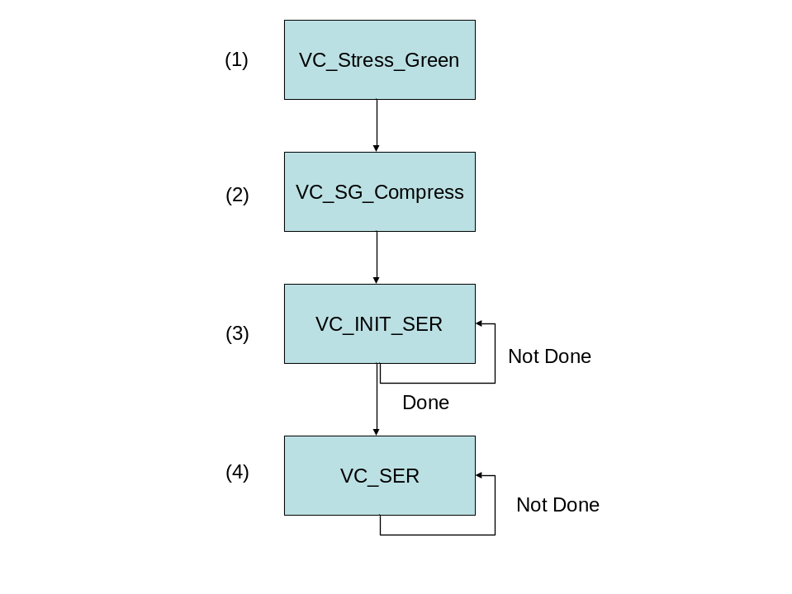
Figure 1 The VC code sequence.

As input to step (1), VC uses both static fault models and dynamic fault properties (friction) for calculating the stress Green’s functions. VC fault models are already an extensive part of the QuakeTables [QuakeTables] fault database system. The calculations of the Green’s functions may be replaced by GeoFEST. As we discuss below, this will allow much more realistic fault models to be incorporated into VC.

VC performs simulations of the time evolution of interacting fault ruptures and stresses. It does so by making use of tabulated Green's functions which provide the change in stress tensor at the "ith" fault in the model caused by unit displacement on the "jth" fault in the same model. The simulation is given some initial conditions (and perhaps tuning of parameters) and set in motion. The Green's functions are derived from the analytic expressions for elastic dislocation due to strike slip faults in a uniform elastic half space.
While the approach is quite powerful and general, it incorporates some physical simplifications. Principal among these is the assumed elastic uniformity of the Earth required by the analytic solutions. Also difficult (though perhaps possible) to incorporate in the analytic VC formulation are anelastic (that is, viscoelastic) rheological effects and faults other than vertical strike slip.
GeoFEST, being a (numerical) finite element simulation approach, readily accommodates nearly arbitrary spatial heterogeneity in elastic and rheological properties, allowing models that are more "geologically realistic" to be formulated. Given the needed mesh generation capability, it also provides a means to simulate faults of arbitrary orientation and sense of motion. The proposed project aims to use GeoFEST to run a succession of models, each with a single fault patch moving. The result will be a tabulation of numerical Green's functions to plug into VC in place of the analytic ones. Although initial efforts aim at reproducing and slightly extending the presently established elastic VC results, subsequent work could involve the generation of time dependent Green's functions as well. Very few modifications of either GeoFEST or VC are anticipated, although the generation of potentially hundreds of successive GeoFEST runs, each with differently refined meshes, may require some dedicated work on batch processing of mesh generation, submission and post-processing tasks.

Implementation details are described in “CCE Exploration Scenarios.”

Data Assimilation and Mining Applications: RDAHMM
RDAHMM (Regularized Deterministically Annealed Hidden Markov Model) is also described in more detail in documents available from the QuakeSim web site. In summary, RDAHMM calculates an optimal fit of an N-state hidden Markov model to the observed time series data, as measured by the log likelihood of observed data given that model. It expects as input the observation data, the model size N (the number of discrete states), and a number of parameters used to tweak the optimization process. It generates as output the optimal model parameters as well as a classification (segmentation) of the observed data into different modes. It can be used for two basic types of analysis: (1) finding discrete modes and the location of mode changes in the data, and (2) to calculate probabilistic relationships between modes as indicated by the state-to-state transition probabilities (one of the model parameters).

RDAHMM can be applied to any time-series data, but the GPS and Seismic catalog data are relevant to the CCE. These data sources are described in detail in [Parker2004]. RDAHMM integration with web services supplying queryable time series data is described in “CCE Exploration Scenarios.”

Coarse Graining/Potts Model Approaches
This application represents a new technique that we are developing as part of the AIST project. Since, unlike the other applications, this technique has not been previously documented in detail, we describe it in more depth here.

Models to be used in the data assimilation must define an evolving, high-dimensional nonlinear dynamical system, that the independent field variables represent observable data, and that the model equations involve a finite group of parameters whose values can be optimally fixed by the data assimilation process. Coarse-grained field data that will be obtained by NASA observations include GPS and InSAR. For example, we can focus on coarse-grained seismicity data, and on GPS data. For our purposes, the seismicity time series are defined by the number of earthquakes occurring per day on the .1º x .1º box centered at x_{k}, s(x_{k},t) = s_{l}(t). For the GPS time series, the data are the time-dependent station positions at each observed site x_{k}. Both of these data types constitute a set of time series, each one keyed to a particular site. The idea of our data assimilation algorithms will be to adjust the parameters of a candidate model to optimally reproduce the time series from the model. We also need to allow for the fact that the events in one site x_{k} can influence events in other boxes x_{k’}, thus we need an interaction J_{k,k’}. We assume for the moment that J is independent of time. We must also allow for the fact that there may an overall driving field h that affects may affect the dynamics at the sites.

Models that we consider include the very simple 2-state Manna model [Manna1991], as well as the more general S-state Potts model [Amit1984], which is frequently used to describe magnetic systems, whether in equilibrium or not. The Manna model can be viewed as a 2-state version of the Potts model, which we describe here. The Potts model has a generating function, or energy function, of the form:

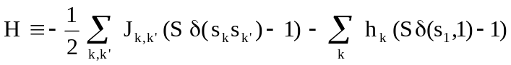 (1)

where s_{k}(t) can be in any of the states s_{k}(t) = 1,...,S at time t, δ(s_{k},s_{k’}) is the Dirac delta, and the field h_{k} favors box k to be in the low energy state s_{k}(t) = 1. This conceptually simple model is a more general case of the Ising model of magnetic systems, in which case S = 2. In our case for example, the state variable s_{k}(t) could be similarly chosen to represent earthquake seismicity, GPS displacements of velocities, or even InSAR fringe values.

Applying ideas from irreversible thermodynamics, one finds an equation of evolution:

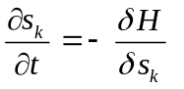 (2)

or

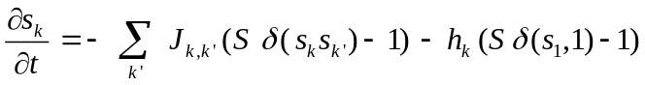 (3)

The equation (3) is a now a dynamical equation, into which data must be assimilated to determine the parameter set {P} ≡ {J_{k,k’}, h_{k}}, at each point x_{k}. Once these parameters are determined, equation (3) represents the general form of a predictive equation of system evolution, capable of demonstrating a wide range of complex behaviors, including the possibility of sudden phase transitions, extreme events, and so forth.

General Method: The method we propose for data assimilation is to treat our available time series data as training data, to be used for progressively adjusting the parameters J_{k,k’} and h_{k} in the Potts model. The basic idea is that we will use a local grid, or cluster computer, to spawn a set of N processes applied to simulate the K time series. The basic method depends on the following conditions and assumptions, which have been shown to be true in topologically realistic simulations such as Virtual California.

- Earthquake activity is presumed to be fluctuations about a steady state, so that all possible configurations of a given model (“microstates”) are visited eventually. Seismicity is also presumed to be an incoherent mixture of patterns, as a result of the correlations induced by the underlying dynamics. Practically speaking, this means that if we have a basis set of patterns, our task is to find the combination of patterns generated by a model to optimally describe the data. For earthquake data, it is observed that there are approximate cycles of activity, also known as variability, that produce earthquakes.

- We have a set of observed time series for many spatial positions of earthquake-related data (observed time series, see data sources in [Parker2004]). We wish to find the set of model parameters that optimally describe these data (optimal model parameters). Our task is complicated by the fact that, even if we knew the optimal model (or optimal model parameters), we do not know the initial conditions from which to start the model dynamics so as to produce the observed time series.

We wish to evolve a method that locates the optimal model parameters, subject to the caveat that the initial conditions producing the observed data will be unknown, and that as a consequence, even the optimal earthquake model will display great variability that may mask the fact that it is the optimal model. Our data assimilation method will therefore be based on the following steps.

- We describe our observed time series as a space-time window of width (in time) = W. The spatial extent of our window is the K spatial sites at which the time series are defined.

- We define a fitness function (or cost function) for each simulation F(T,i), where i is an index referring to a particular simulation, and T is the offset time since the beginning of the simulation at which the fitness is computed. F(T,i) measures the goodness-of-fit between the observed time series in the observed space-time window of width W in time and K sites in space, with a similar width space-time window of simulation data covering the times (T,T+W), and over all K sites. We overlay the observed time series of width W over the simulated time series, advancing T a year at a time, until we find the value of T that provides the optimal fit of simulated time series to observed time series simultaneously at all K sites. The goodness of fit is determined by the value of the fitness function F(T,i). For any set of N processes, we will determine the functions F(T,n), n = 1,...,N, to find the simulation, call it n_{o} , that yields the optimal value F(T,n_{o}).

- The steps in our data assimilation algorithm will then be:
  - Beginning with an initial model (initial values for set of model parameters {P}), generate random perturbations on {P}, denoting these by {P_{r}}, r = 1,...,N.
  - Spawn N processes, each with its own set of parameters {P_{r}}, and generate a set of simulation data time series that is long (in time duration) compared to the data window width W, duration time t_{D} >> W.
  - Compute F(T,n), for all n = 1,...,N, and determine the optimal model F(T,n_{o}).
  - Adopt the parameter set {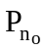} for the optimal model as the “new initial model”, and repeat steps a.-d. iteratively until improvement in F(T,n_{o}) is no longer found.

Result: Once the a finalized version n_{f} , corresponding to parameter set {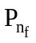}of the optimal model is found, together with the optimal value T, the events in the time interval Δt following the time T+W can be used as a forecast of future activity. Once the time interval Δt is realized in nature, the window of observed data of width W can be enlarge to a new value W → W + Δt and the data assimilation process can be repeated.

This system, as described, is a relatively straightforward parallelization problem. However, it also lends itself to cooperating Grid service versions, in which nodes may cooperate through events and a controlling shell manager. We will investigate the use of the NaradaBrokering system in this case to manage these such high throughput applications.

CCE Data, Representations, Queries

Data Sources, Queries, and Filters
CCE data sources (and the CCE applications that use them) are described in the Coupling Methodologies paper. In brief summary, we must work with the following data:
- Earthquake fault models, such as provided by the QuakeTables project [QuakeTables].
- GPS data
- Earthquake event/seismic data.
These data sources are available online. For a comprehensive review of GPS and Seismic data, see [Parker2004] and also http://grids.ucs.indiana.edu/~gaydin/servo/. As part of the AIST project, we have developed GML-based data descriptions, relational database systems, and web services for accessing these data sources programmatically through query filters (such as SQL and XPath).

Current limits in our approach are that we cannot pose queries that span multiple data sources. For example, SCSN, SCEDC, Dinger-Shearer, and Haukkson data formatted earthquake events can be searched and filtered individually, but we cannot query these simultaneously.

We will investigate meta-query tools that can construct queries across related but differing data models. These meta-query capabilities will be directly used in the pipelined applications (particularly RDAHMM and the Potts model codes) described below.

Ontology Architecture

Web services provide solutions for message and file exchange. We propose to include the Federated Database Service in the Complexity Computational Environment. The Federated Database Service achieves data integration for web service clients. In order to accomplish data integration tasks, a programming level of semantics, application semantics, is abstracted into an ontology structure to assure SERVOGrid capability. The Application Semantics level is dedicated to manage the metadata extracted from the Application level, and to incorporate ontologies into the data integration processes.

The purpose of the Ontology Architecture is to accomplish the Federated Database Services in the Application Semantics level. Meta-ontologies, the ontology and metadata authoring tool, and the data integration API complete the Ontology Architecture. Federated databases require delicate management of metadata. Different data sources indicate different database schemas or metadata representations. Ontologies facilitate the metadata management in the Ontology Architecture.

Specifically, an ontology is a collection of concepts and relationships among these concepts. Metadata or their synonyms are represented as concepts in an ontology. Ontologies serve to describe individual data sources, and a meta-ontology (or ontology interconnections) supports information sharing [Aslan1999] in the Federated Database Service. Relationships in ontologies are either manually or semi-automatically defined; the latter us accomplished by incorporating data mining techniques. One of the data mining techniques, Topic Mining [Chung2003], is able to determine the concepts and relationships among those concepts from stream data.

The initial ontology structure when have developed for one of our key data resources, the QuakeTables database, results from the combined efforts of domain experts and computer scientists. Each local database in the Database Architecture is associated with an ontology. A browser-based authoring tool is implemented for manual ontology management and evolution. The data integration is performed by the data integration API, the semantic-based wrapper, in the architecture. The semantic-based wrapper facilitates the Federated Database Service. The semantic-based wrapper interprets metadata from different data sources according to the meta-ontology and ontologies. After the data integration process performed by the semantic-based wrapper, the retrieved data from several data sources is then presented as a unit to the requestor. Users receive abundant and integrated data from the Federated Database Service without dealing with synonyms of metadata, difference of data organizations and formats, and integration of retrieved results.

Database Architecture
The components implemented in the upper level of the database architecture are the semantic-based query generator and task pool manager. On the bottom level of the database architecture, heterogeneous data sources are loosely united by the components in the upper level. Local databases contain their own ontologies. In the architecture, data sources are not restricted to relational database management systems. Although we include Oracle and MySQL in the current implementation, the architecture is compatible with new data sources. Compatibility is provided by including the new metadata in the ontology architecture and by incorporating connection information into the task pool manager. The semantic-based query generator refers to the meta-ontology in the ontology architecture and translates user queries into other query languages. Examples of compatible query languages are SQL and XQuery. The task pool manager requests to establish connections with database management systems or data source agents. Once the connections are established, queries are sent to the data sources and result sets are provided to the semantic-based wrappers for the data integration process in the ontology architecture.

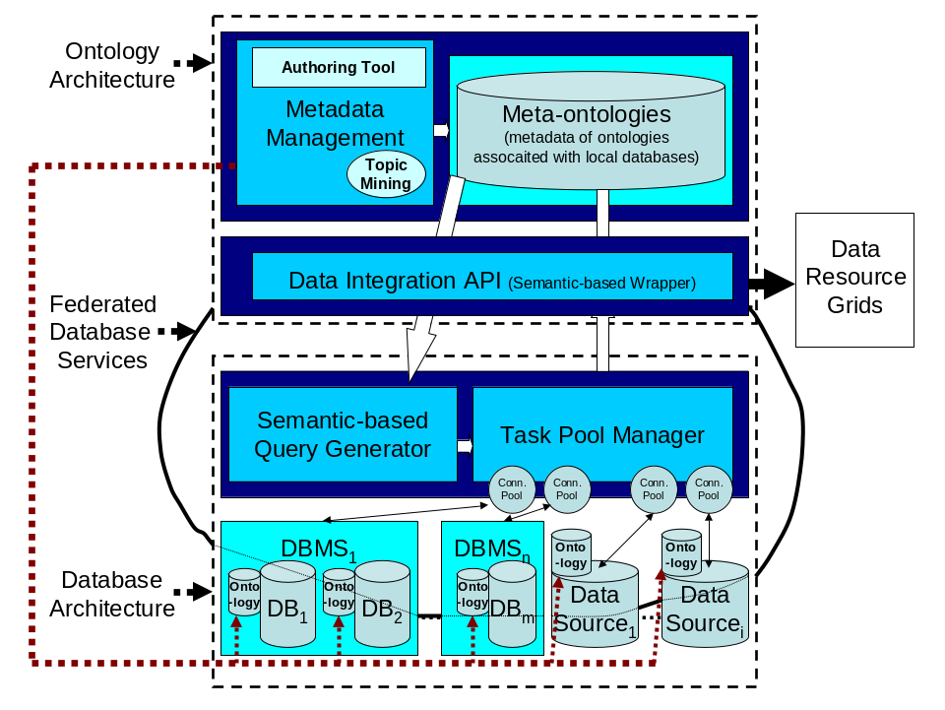
Figure 2 Combined Ontology and database architecture.

Grids and Web Services: Background, Trends, and Lessons
The CCE system that we propose is an implementation of higher level functionality (workflow and computational steering through physical modeling) on top of a Grid service infrastructure. Services are basic units of functionality, capable of such tasks as accessing databases, moving files between host computers, running and managing applications, etc. These may be built in a number of ways: the Globus Toolkit represents one approach. We adopted a “Web Services” approach based on WSDL for service interface descriptions (how a service is invoked), and SOAP for inter-service communication message formats.

Much of this initial infrastructure was developed under the previous project, QuakeSim [QuakeSim], as a web service-based grid. The computational Grid world has evolved rapidly (and controversially) since the initial design of the QuakeSim system. We believe that time has proven most of our initial choices in the earlier system to be correct: Grids may be built from Web Services. Customized extensions to Web Services, originally proposed in the OGSI specification, are to be avoided, and instead we should follow the broader trends in the Web Service world, as driven by such organizations and the W3C, OASIS, and WS-I.

Web Service Basics
Web Services are essentially built on top of two major specifications: WSDL and SOAP. WSDL describes the remote service’s interface (its methods, their arguments, their return types), while SOAP is a messaging format that encapsulates the communications (in XML) between the services.

Technically, the two are decoupled: you can build services described with WSDL that use other messaging protocols besides SOAP. There has always been at least an implicit debate in the Web Service community on which of the two is more fundamental. Those who have emphasized WSDL (such as the OGSA community) have been lead to view Web Services as distributed objects, while those who have emphasized SOAP (or, at least the messages over the interfaces) have been attracted to the more loosely coupled service-oriented approach. We examine these differences in the next section.

Web Service Grids and Service Oriented Architectures
Since our initial design and implementation of QuakeSim, one of the most important debates in the Grid Service community has been on the appropriate architecture of these systems. The two opposing approaches are distributed object systems (represented by the OGSI specification and its implementations) and the service oriented architectures (SOA).

Distributed objects and services differ in subtle ways: you may implement either approach using WSDL and SOAP. CORBA is the quintessential distributed object system, and many Web Service developments have closely followed the CORBA approach from the 1990’s, making the distinction fuzzy. Both approaches are built of distributed “components” that expose public interfaces and communicate through specified message protocols. In a nutshell, the primary differences in the two approaches are these:

Distributed object systems allow for “stateful” interactions. That is, the remote object has publicly accessible data that clients can modify through methods. In SOA systems, this is expressly forbidden: clients may not directly manipulate the state of the more service. Instead, if required, state may be maintained a conversation between the components. HTTP cookies are a common example of stateful conversations.

Distributed object systems have tended to focus on remote method invocations (the object-oriented equivalent of remote procedure calls). The remote object is intended to be used as if it were a local object: developers program applications using client stubs that can be treated as local programming objects, but which must in reality make remote calls to the “real” object, blocking until the method returns. This approach is suitable for tightly coupled environments like enterprise intranets, but it does not scale well to the loosely coupled situation seen, for example, in most Grid applications that need to run in several different, autonomous locations. SOAs instead focus on the message itself, rather than its invocation. Since interactions are normally stateless, message traffic between two components is assumed to be decoupled.

We believe that this debate in the Grid Service world has essentially been won by the SOA approach. The “distributed object” approach used by OGSI has been abandoned for a number of reasons and has been replaced by the newer Web Services Resource Framework. Grid systems by their nature are not deployed on intranets. They instead involve collections of services offered many different service providers who have temporarily aggregated themselves into a “virtual organization.” Message-based, stateless grids meet these requirements for loose coupling.

Message-oriented, loosely coupled systems do require a certain level of tolerance for latency. Classic MPI communications in cluster environments with good networking take place on the order of microseconds. In contrast, internet-based messaging between services has a time scale of milliseconds, so communications are inherently 100-1000 times slower. We therefore may backwardly define “loosely coupled” as meaning any system that does not need for its components to communicate at speeds less than a millisecond. The Coupling Methodologies paper examines these requirements in some detail for the CCE. To summarize:
- Couplings involving autonomous application runs that take minutes to days to complete are good candidates for the messaging approach. This covers most of the current CCE applications.
- Couplings requiring microsecond latencies, such as adaptive mesh refinement as part of GeoFEST, are not appropriate for the Grid Service approach. Instead, these should use the more appropriate MPI approach and be deployed on specific clusters.
- In between these extremes, we have interactive visualization services, which require high speed internet messaging performance (i.e. milliseconds). These may be implemented with the messaging approach but will push the boundaries of performance and Web Service messaging infrastructure.

In building the CCE grid, we will adopt the message-based, SOA approach.

Managing WS-<any> Specification Glut
With the key Grid Service architectural debate apparently resolved, we must now face the consequences: proliferation of would-be standard extensions to the basic approach. Web Services (and Grid Services) may be spawned out of a number of specification bodies, including primarily the World Wide Web Consortium and OASIS. At the time of writing, there are over sixty different specifications, many of them with overlapping and competing concerns, many others strategically linked in “roadmaps” that attempt to ensure adoption through specification dependency.

In order to resolve this situation, we advocate a conservative approach that follows the WS-I interoperability approach. WS-I’s charter is to promote interoperability in various implementations of Web Service specifications from different vendors running on different platforms and supporting different languages. Many of the WS specifications are not written with any simultaneous implementation/interoperability tests, and without requirements for completely independent implementations, so there are inevitably uncertainties, ambiguities, and plain old bad decisions in the specifications. WS-I exists to clarify/refine these specifications after the fact.

WS-I however wields more influence than is apparent in its bland charter. By putting specifications through the crucible of interoperability, it has effectively blessed these specifications as being part of the web service core: they have a sufficient number of independent implementations to warrant the interoperability tests in the first place. We will thus adopt the approach that WS-I defines core specifications, and proposed Grid Services that require modifications (rather than standard extensions) to these specifications will not be adopted. For example, an approach based on WSDL 1.2 or 2.0 will not be used to build the CCE grid unless it passes the WS-I test.

The WS-I profile is unquestionably insufficient and must be expanded over time. The current profile consists only of the XML schema, WSDL 1.1, SOAP 1.1, UDDI, and SOAP Message Security. Many other capabilities are needed by service/message oriented grids, such as
- Support for notification and events (WS-Notification, WS-Eventing).
- Numerous security issues such as federation, policy expressions, and secure conversations (the WS-Security specification family).
- Support for richer metadata than provided by current UDDI (WS-Resource)
- Support for dynamic discovery of services and their descriptions (WS-Discovery).
- Support for more sophisticated addressing in SOAP messages to handle such things as firewall tunneling and dynamic service instance locations (WS-Addressing)
- Support for reliable messaging (WS-ReliableMessaging).
- Workflow (BPEL)
We have indicated in parentheses some relevant W3C or OASIS specifications, although there is no guarantee that these specifications in their current form will actually make it into the WS-I portfolio.

The approach of the UK e-Science program is to assume that the basic WS-I portfolio will be slowly expanded over time to include more and more specifications. The UK’s Open Middleware Infrastructure Initiative (OMII) refers to this as the “WS-I+” approach: new service specifications will be carefully added to the core specification list

In building the CCE Grid, we will follow the WS-I+ approach of the OMII and will utilized their implementations where they are available.

Grid of Grids
We end this section with some conclusions that we may draw from the general approach described above. First, a Grid is not really formally defined, but we may view it as a collection of capabilities provided by different organizations that have banded together to form a “Virtual Organization.” A capability is just a Web Service, and Grids may be built from collections of Web Services. A Grid Service is just a Web Service, although it may follow more restrictive conventions defined by OGSA. It is actually better to define a Grid by how it is used rather than how it is built.

Typical Grid services may be organized into related groups of components. A partial list of example Grids include
- Visualization grids
- Data grids
- Computing grids
- Sensor/streaming grids
- Audio/video collaboration grids
Each is essentially a type of service that may be implemented on some real sets of systems. These might be of interest in their own right, but really they are intended to compose larger, application grids. The CCE grid is an example of this approach: we need to build it out of all of the component grids listed above. We may continue to follow this hierarchy: the CCE grid itself may be part of a Crisis Planning, Management, and Response Grid. We refer to this as a “Grid of Grids.”

Building Message-Based Services
Grid and Web Services that adopt the SOA approach need a messaging infrastructure for exchanging information. In particularly, the SOAs must enable the features that are part of the SOAP 1.1/1.2 specifications, particularly intermediate message header processing. They must also provide support for WS-I+ specifications like security, events and notification, reliable messaging, message routing, etc.

In this section we review our approach to implementing the messaging environment for the CCE Grid. We first review the Community Grid Lab’s NaradaBrokering messaging/event system. We then examine integrating NB with Web Services, implementing reliable messaging and fault tolerance.

NaradaBrokering for Grid Service Messaging
The Community Grids Lab has for several years been developing a core messaging infrastructure, NaradaBrokering (NB), that can handle sophisticated, many-to-many messaging over numerous transport protocols. Applications of NB have focused on collaborative systems such as Anabas and GlobalMMCS. We have, however, been adapting NB to implement and be compatible with Grid and Web Service specifications.

A full description of NB is out of scope for this document; references available from http://www.naradabrokering.org provide full descriptions of the system. In brief summary, it acts as publish/topic/subscribe system that enables communication between distributed components running on different hosts. Publishers and subscribers are autonomous, distributed computing components that have write and read access (respectively) to various topics. Any given entity may be both a publisher and subscriber to a particular topic, and entities may have different roles in different topics. Both publishers and subscribers connect to message brokers, which are responsible for routing messages and maintaining topic lists. On top of this basic system, we may build a number of more sophisticated features: for example, brokers may be distributed, may change the protocols and ports used to transport messages, may guarantee delivery, may enforce security, may ensure once-only delivery and persistent storage of messages, and so on. In terms of SOAP messaging, distributed brokers may act as relay nodes and may process SOAP headers.

The following table summarizes the most important (and relevant) NB features.

Multiple transport support  In publish-subscribe  Paradigm with different  Protocols on each link | Transport protocols supported include TCP, Parallel TCP streams, UDP, Multicast, SSL, HTTP and HTTPS.  Communications through authenticating proxies/firewalls & NATs. Network QoS based Routing
Subscription Formats | Subscription can be Strings, Integers, XPath queries, Regular Expressions, SQL and tag=value pairs.
Reliable delivery | Robust and exactly-once delivery of messages in presence of failures
Ordered delivery | Producer Order and Total Order over a message type  Time Ordered delivery using Grid-wide NTP based absolute time
Recovery and Replay | Recovery from failures and disconnects.  Replay of events/messages at any time.
Security | Message-level WS-Security compatible security
Message Payload options | Compression and Decompression of payloads  Fragmentation a nd Coalescing of payloads
Messaging Related Compliance | Java Message Service (JMS) 1.0.2b compliant  Support for routing P2P JXTA interactions.
Grid Application Support | NaradaBrokering enhanced Grid-FTP. Bridge to the Globus TK3.
Web Service reliability | Prototype implementation of WS-ReliableMessaging

Table 2: NaradaBrokering features.

One of the main goals of NB has been to virtualize communication connections, building a buffer layer between applications and the lower level networking infrastructure (TCP/IP, UDP, etc). This is motivated by a number of concerns:
- Collaborations and virtual organizations are often constrained or disabled by firewalls, NATs, and other networking features. Both Grid computing and Audio/Video collaboration are prominent examples of technologies crippled by current real networks.
- The ideal protocol for a given collaboration may change over time, may be different for different recipients participating in the same activity, and may be a mixture of two or more “real” connections in the same “virtual” connection. For example, a participant behind a firewall/NAT in an AV collaboration may be unreachable by UDP, so we may need to tunnel the transmission through the NAT. GridFTP over NB is an example of dual transmissions in the same virtual connection: control messages are sent back and forth over one connection (which may be reimplemented as SOAP in a hypothetical Web Services version), while transmissions of data go over a separate data channel.

NB-style virtual connections have another potential long term application. For web services requiring high (true millisecond) performance, SOAP over TCP/IP is notoriously inefficient. By virtualizing connection through NB brokers, transmitting messages over high speed UDP connections, and using the NB messaging fabric to provide in the application layer typical TCP/IP features like reliability, SOAP messaging performance may be increase by 2-3 orders of magnitude [Fox2004].

Integration of NaradaBrokering with Grids and Web Services
We have three potential integration strategies, summarized in Figure 3. First, there is the proxy approach, in which NaradaBrokers masquerade as remote Grid/Web Services. The brokers intercept the incoming messages and route them (unaltered) to the remote service. In this approach, the messages partake in NB Quality of Service features as long as they are within the boundaries between the end proxies. The connections between the proxies and the external endpoints are not covered by NB. One may adopt this approach when the remote web service is normally unreachable (due to firewalls) or when one wishes to hide the actual service’s or client’s URL. It also allows legacy implementations to be naradasized with minimal alteration. We have adopted this approach for GridFTP tunneling and have also tunneled ordinary SOAP messages this way.

Second, we may follow the approach of directly integrating SOAP support into NB (middle of Figure 3). Here the services are also brokers and send SOAP messages directly over NB virtual connections. We may insert any number of brokers in between the two services, which may act as SOAP relay nodes. At the time of writing, implementation of direct SOAP support is being completed. We expect this to be the long term approach that we will follow in the CCE.
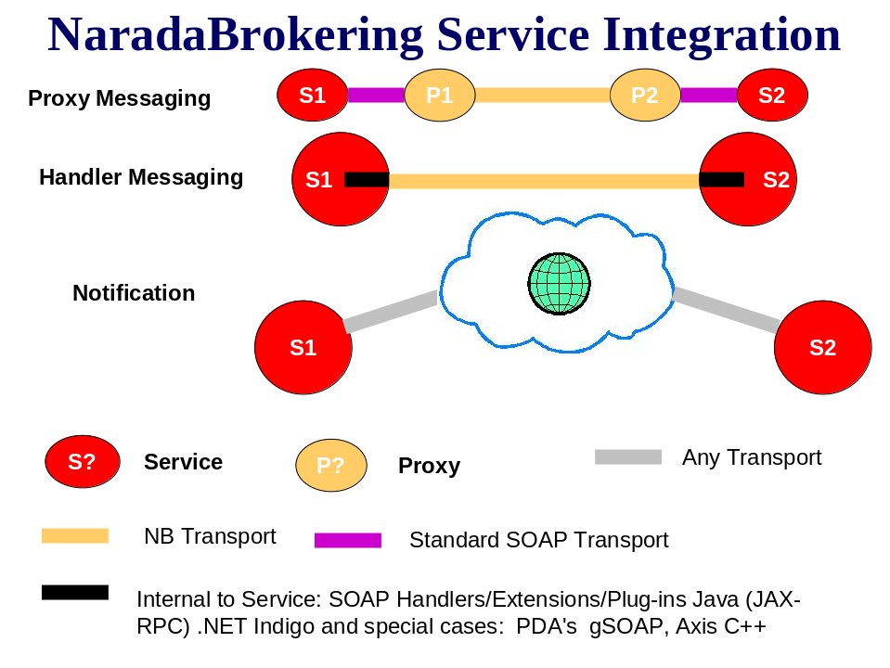
Figure 3 Approaches to integrating Narada and Services.
Finally, NB may be used to send events/notifications between services. Relevant specifications include WS-Notification and WS-Eventing. This is somewhat different than the first two approaches, and will coexist with them. In the first two cases, we have pull messages: we are invoking the service’s main interface and have an expected behavior from the service. In the last case, a service that is part of a cooperating group of services may need to notify its other partner services of various events (such as “I’m alive” or “I’m going away” in the simplest cases.) It is up to the event recipient to decide what to do. This is an example of push messaging.

Proxy messaging and handler messaging are alternatives to each other. Notification can by used by services in either case.

Reliable Messaging
Messaging in SOA-based grids often requires reliable messaging: the message originator usually needs to know if the message was actually received by the designated endpoint. Two competing specifications (WS-ReliableMessaging and WS-Reliability) provide straightforward solutions to this problem through acknowledgement messages. In both cases, the reliability Quality of Service capability is implemented as a SOAP header element that goes along with the normal SOAP message body.

Interestingly, the reliability approaches closely resemble the TCP/IP mechanisms, but in the application layer of the protocol stack. That is, reliability is an example of duplicating (previously considered) core networking functions in the application layer. Thus, we may use application layer reliability (implemented in SOAP messages sent over NB) to send messages over higher-performance UDP, eliminating the redundant TCP/IP features. We have implemented WS-ReliableMessaging and are in the process of integrating it with NB SOAP support.

Fault Tolerance
Reliable messaging is somewhat misnamed, as it does not define what should happen if messages actually fail to arrive; rather, it just is a mechanism for communicating failure or success. We may sweeten the implementation by providing some additional guarantees of delivery through fault tolerant messaging. Here, messages that partially or completely fail to reach their endpoints may be resent. This requires features such as persistent storage and once-only delivery.

Core CCE Infrastructure: Internet-on-Internet (IOI)
In the previous section we have previewed an interesting and important development in Web Services: they are beginning to mimic the capabilities of the lower level network within their messages and messaging implementations. Reliability and fault tolerance are two prominent examples.

We think this development is important for reasons previewed above. We refer to this as the “Service-Internet-on-Bit-Internet,” or IOI. IOI is essentially a reimplementation of standard low-level networking capabilities at the higher application level.

Typical IOI capabilities include several items listed previously:
- Support for multiple transport protocols
- Support for many different message delivery protocols, such as reliable delivery, once-only delivery, ordered delivery, and persistent delivery/delivery replay.
- Application-level performance optimization through compression/decompression.
- Fragmentation/coalescence of messages, which may be delivered over separate routes, in parallel. One may use this to do higher performance file transfers and to increase the reliability of large file transfers.
- Security services, such as message encryption and authorization.
- Time stamping services to assist with ordered delivery and replay.
- Congestion control and dynamic best-route determination.
- Performance monitoring.
- Ad-hoc network support
- Broker discovery for internal NB network management.
- Topic discovery
- Native NB support for SOAP

All of these are traditional “low-level” networking capabilities that can be re-implemented in the NB fabric layer, on top of traditional networking.

High Performance SOAP: Interestingly, the implication of Web Service standards is that we can mimic the TCP/IP layer directly in the SOAP header and use the much higher performance UDP for exchanging SOAP messages. We are investigating this development. We see it as extremely useful for interactive applications that demand higher performance out of services, although it is not a requirement in any of our application scenarios.

We may also use broker topologies to mimic network topologies, creating overlay networks, “virtual private grids”, firewalls, and demilitarized zones.

Core CCE Infrastructure: Context and Information Environment (CIE)
In addition to the IOI capabilities, we have a number of other requirements needed to manage grids and services. That is, if implemented correctly, the IOI fabric may be invisible to the applications that run in it. Although an application developer may conceivably want to directly touch this layer, this would not be standard. Instead, they would specify the desired Quality of Service and let the IOI fabric implement this.

There are a number of higher level services and capabilities that do not belong in the IOI layer. As a general rule, these are services that extend (rather than mimic) the lower level networking features and are more specifically needed for Web service management. Typical examples include service information and metadata management. We refer to this collection of capabilities as the Context and Information Environment.

The basic problem is the following: which service or sequence of services actually accomplishes my desired calculation? In our Grid of Grids approach, there are various service collections that provide the basic capabilities of the CCE. There are execution services for running remote applications and orchestrating cooperating services, there are data grid services that provide access to remote data, there are collaboration services, etc. These services are used to build “useful” grids for CCE applications and are maintained in an IOI fabric that is responsible for the messaging infrastructure and the related qualities of service. The relationship of the IOI to the CIE is shown in Figure 5.

In the Grid of Grids approach, the services must share “higher level” information about themselves. This is commonly called metadata. We may extend this to the problem of building “information grids” and “knowledge grids” that build on the more traditional “execution” and “data” grids.

The problem in the Grid and Web Service world is that the metadata/information problem for describing services is very confused.
- The WS-I has effectively endorsed UDDI, but it has a number of problems (rigid data models that don’t describe science Grids very well, no mechanisms for dynamic service discovery and clean up, to name two.)
- The Semantic Web has worked for a number of years on metadata descriptions and more sophisticated knowledge management, but tends to get ignored by the Web Service community, at least in the US. DARPA has tried to refocus its part of the Semantic Web work into service descriptions.
- The Grid community has two competing concepts (the WSRF specification suite and WS-GAF) on managing metadata, particularly when it concerns dynamically evolving resource state information.
- From OASIS we have the WS-DistributedManagement suite of specifications and WS-MetadataExchange.

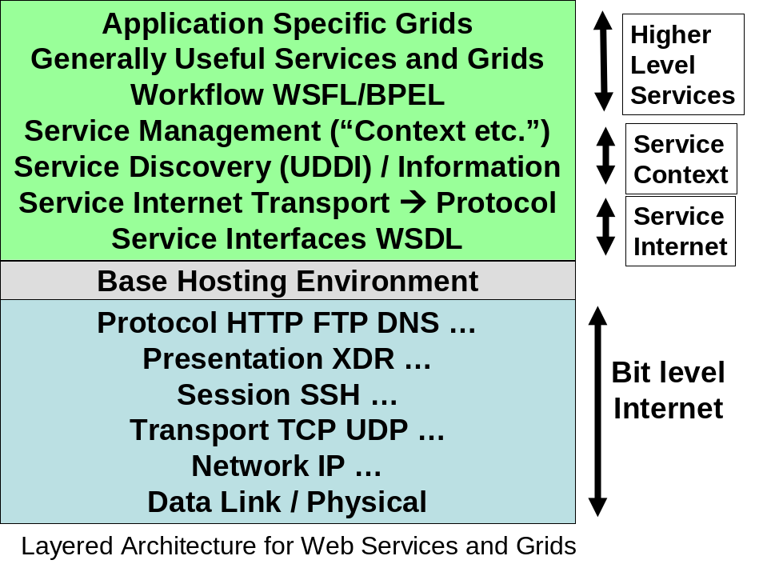
Figure 4 Layered architecture for Web Services and Grids.

Controller Environments for CCEs: Portals and Scripting
The CCE will build upon the QuakeSim portal technologies developed in the original NASA Computational Technologies project. The CCE Portal will allow universal access and minimize requirements on the user’s desktop. However, portals will not be the only way of interacting with the system. The CCE system needs a more suitable framework for development by application scientists. Experience in the NASA CT project has shown that these developers need a scripting environment for interacting with services: they need to couple their applications to other services, but the actual workflow chain may need to be altered frequently. Once scripts have been finalized, they need to be incorporated into the portal.

Portals
The QuakeSim portal was a pioneer project in applying the portal component concept (“portlets”) to computing portals. This has been thoroughly documented on the QuakeSim project web site and in several publications. The portal field has undergone important changes since the portal was implemented. Two important specifications, JSR168 and WSRP, have emerged that may standardize much of the portal component work so that it may be shared across vendor containers. In summary,
- JSR168 defines a standard local portlet API in Java. JSR 168 compatible portlet engines can load each other’s portlets. Examples of JSR168-compatible portlet containers include WebSphere, Jetspeed2, uPortal, and GridSphere.
- WSRP defines a standard remote portlet API in WSDL. That is, the portal runs separately from its container.

These two standards are compatible: JSR168 compatible portlets may act as proxies/web service clients to the remote WSRP portlets. Both standards have shortcomings (some possibly serious) and both have reference implementations that will need improvement, but we expect portlet containers to support them nonetheless.

The CCE project will migrate to JSR168 and/or WSRP portlets. We will follow the lead of other projects, particularly the NMI OGCE portals project and the DOE Portal Web Services project.

Scripting Support for Web Services
The Service Oriented Architecture makes a clean separation between services, messages, and user interfaces. It is possible to build more than one client interface to the same remote services. This has a very clear value in the CCE project, since typical CCE applications (described below) require many different services to be orchestrated in a single application. We have explored workflow engines based on Apache Ant for solving this problem in previous work. While Ant provides a large number of useful built in tasks (mostly for interacting with remote operating systems), it has several severe shortcomings:
- It is not a real scripting language, so conditionals, loops, and other control structures are difficult or impossible to implement.
- It therefore is difficult to author scripts. The XML expression of tasks is less intuitive to script developers than the more familiar scripting languages.
- It is therefore difficult to develop new task scripts, as the portal/service developers must author these based on the geophysicist developer’s specification. This discourages the application developers from rapid prototyping and otherwise changing their scripts.

We have developed a scripting environment for remote services, HPSearch, that can be used to manage the flow of orchestrated services. HPSearch uses the Mozilla Rhino implementation of Javascript as the scripting engine, but in principal other scripting engines (particulary Jython) may be used. HPSearch is also integrated with NaradaBrokering.

HPSearch scripting will be used initially by the portal/service developers as a replacement for Apache Ant solutions for workflow. Because Rhino is implemented in Java, it will be straightforward to integrate it into our Apache Axis-based service implementations. We further anticipate by the end of the project this scripting environment will be adopted by some of the application developers for prototyping their projects.

A detailed description of HPSearch is out of scope for the current document but may be found in [Gadgil2004].

Security Requirements
The CCE system, and SERVO in general, have two main categories:
- Securing data, application, results, and other intellectual resources
- Securing hardware resources

Applicable security concepts are
- Authentication or proof of identity.
- Authorization or access rights associated with an authenticated identity.
- Privacy and encryption
- Data integrity

In SERVO development, we concentrate on applying security concepts to intellectual resources rather than hardware resources. For the latter, we will comply with existing security mechanisms in place at participating sites. These sites tend to focus on known, standard solutions such as Kerberos, Globus/GSI, and SSH. One development challenge facing us during this project will be to support one-time password systems that are being deployed at many NASA sites.

These are widely addressed problems in the grid community and we will adopt solutions available from the community.
- The current SERVO project uses SSH/SCP to access NASA JPL resources whenever required.
- We have developed Kerberos mechanisms in the past through the Gateway project for the DOD. Newer developments in Kerberized Java SSH clients by our collaborators are compatible with our current SERVO approach.
- Grid-based centers will be accessed using the OGCE portal components and its Java CoG building blocks.
- We expect the DOE Portal Services project and the DOE Portals Consortium to develop solutions for centers requiring one-time passwords. We are members of this consortium and so will adopt their results.
- Resources that are owned and donated to the project by the CCE team members will use SSL security.

In summary, all secure hardware resource access scenarios that we must support are, or soon will be, solved problems. We will simply provide (in the portal environment) metadata systems and portlet interfaces that can provide the user with the appropriate authentication interface.

We note that we do not attempt to solve the general authentication problem, as in GSI and Kerberos. This is out of scope for the project and depends on the uniform adoption of security mechanisms by all computing centers that we will use. We also note that such solutions are overkill for many of our applications:
- High end NASA HPC resources typically are tied to allocation schemes, so we must support (via ssh, globus, etc) strong authentication here. These resources require remote access using specific user IDs.
- Many other steps may be performed anonymously. Typically codes involve preprocessing and post-processing steps that may be accomplished without explicit log in. Such services can be accessed using more simple security solutions such as SSL.

Securing intellectual resources is a more interesting and open research issue for SERVO. Within the scope of this project, we will assume the following:
- Data sources like QuakeTables are open and public for read access.
- Write access is restricted and requires password login.
- Data output (code results, visualization images, etc.) are assumed to be private to the user and may be accessed only by the owning user. Users will be identified to the remote resources based on their portal identity. Uses will be allowed to access this data, which may be stored in relational databases or on UNIX file systems. We will track file locations through the use of metadata services.

Visualization
We will support visualization by phasing in increasingly flexible capabilities over time. The key features of application visualization support are currently
- insightful color display of data values (such as arrows and contours) with geographic map overlay features;
- editable scripts integrated into the portal workflow system; and
- output graphics in formats compatible with browser-based remote display (such as PDF).

In the current portal system, we have implemented disloc-generated surface displacements integrated with a California map with faults, using the open-source GMT application and sending the map in PDF form to the user within an interactive session. A second application GeoFEST produces a large 3D displacement/stress data set, which has the surface extracted and contoured by the licensed IDL application, producing a PDF file for display within the interactive session. A third method uses the geoFEST output, a digital elevation map, and landsat imagery. It uses the RIVA parallel interpolation and rendering system over many time steps to produce an MPEG animation in the background. The user is notified by portal-generated email when it is complete, including a URL link for download.

Common features are the use of some visualization application that is script-programmable, wrapping of that system for data input/output and workflow control, and generation of browser-compatible output. The variety of applications that are now supported include licensed commercial software, open-source widely used software, and NASA research software, representing a very wide scope of types of visualization software that may be included in SERVOgrid.

The future SERVOgrid system must support a richer visualization environment. An immediate need is the ability to overlay multiple database objects and simulation output details accurately registered within an OGC Web Map Server system. We have developed prototypes of the required OGC services (converting them to Web Services) to accomplish this, and will be applying this to scientific visualization problems as described above.

Future needs include support for computational steering, a richer interactive environment, and three-dimensional GIS-like objects and results. Computational steering requires the ability to subset large data sets, interactively pan and zoom, adjust image parameters like transparency and color table. The richer environment implies the ability to gain a large fraction of the features and resolution of advanced licensed visualization systems within a remote web environment. This might be done by identifying rich distributed tools, or by obtaining a specialized visualization environment tightly coupled to the supercomputing location, that is scripted to be remotely controlled by the portal tools and produce subsetted images suitable for web display.

CCE Exploration Scenarios
The initial phase of the project involved the development of many separate capabilities:
- ontology editors, general purpose metaquery tools,
- web service scripting environments,
- integration of Web Service standards into NaradaBrokering,
- development of GIS services,
- development of data assimilation codes.
These different threads of development will be unified in the following integration projects that will involve participants from all teams.

Data Mining: Integration of RDAHMM with GPS and Seismic Data Sources
We will integrate RDAHMM with GPS and seismic data sets using HPSearch scripting tools. The general scenario is depicted in Figure. This will serve as our model for all several other scenarios.
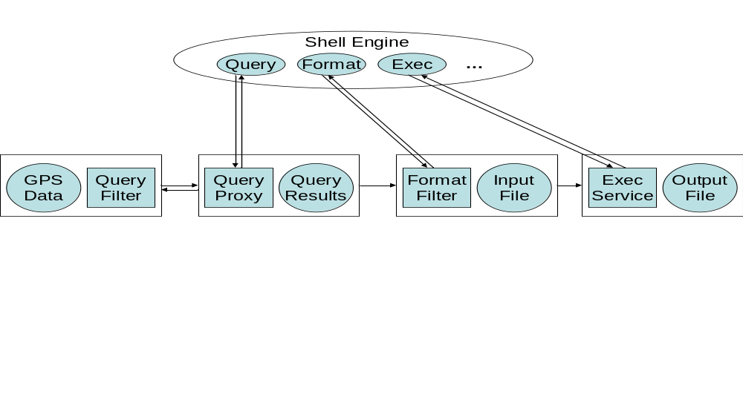
Figure 5 RDAHMM sequence. Transparent rectangles represent distinct hosts.
The specific sequence of events is as follows:
- The shell engine instantiates Query, Format, and Exec components. These are proxies (using HPSearch’s WSProxy clients) to the indicated remote web service. These services and their shell components have the following functionality:
  - Query: construct and execute a remote SQL or similar query on the compiled data GPS data sets. This runs as a “runnable” WSProxy.
  - Format: this is a custom filter that formats the query results into an form appropriate for the execution service; i.e. it creates an RDAHMM input file. This also runs as a runnable WSProxy.
  - Exec: this runs the desired code as a wrapped WSProxy.
- The shell engine then executes the shown flow sequence (Query, Format, Exec,…).
- The Query service is implemented as a Web Service client to the GPS data source. We will initially use the GML-based GPS services developed in Year 1 of AIST funding (which uses SQL queries) but will convert this to the meta-query service in mid-Year 2.
- The Query Proxy retrieves results and notifies the shell engine. The results are published to the selected Format Filter service.
- The shell engine invokes the RDAHMM filter service, which creates an input file. The resulting input file is published to the RDAHMM execution service and the shell engine is notified.
- The shell engine invokes the RDAHMM application and generates an output file.
- This sequence can be extended to include visualization and other post-processing steps.

The initial pieces for running this flow are in place: RDAHMM execution services, and GPS and seismic data services have been developed, as have the HPSearch shell engine and general purpose WSProxy classes. The required tasks are the following:
- Initial integration of GPS data sources with RDAHMM for execution using a command shell.
- Development of portal interfaces to process the HPSearch workflow script.
- Integration of Matlab-based scripts for basic time series visualization.
- Integration of GPS meta-query tools to span multiple GPS repository formats.
- Integration of OGC Web Map Service for map displays of output.

We anticipate that the prototype of this system (steps 1-3, with GPS data) will be completed by the end of September. Examples using seismic data sets will also be developed.

Data Assimilation: Integration of Seismic Data Sources with Potts Model Codes
This flow works essentially the same as for RDAHMM, described above. The Potts model application is still under development. The specific task sequence is
- Develop seismic query services (done in conjunction with the RDAHMM CCE application).
- Develop an appropriate Potts input file filter service.
- Deploy the Potts model code in a generic execution service.
- Integrate with meta-query service that can pose queries across multiple data models.
- Integrate with OGC Web Map Services.

Multiscale Method: GeoFEST and VC Integration
This represents a more difficult integration. As described above, we will use GeoFEST to calculate the Green’s functions for all faults in a large, interacting fault system (California). These faults will then be used by Virtual California to simulate earthquakes.

There are several issues that must be addressed to do this:
- We need to simplify the GeoFEST input creation process. Possible explorations include automating the initial mesh generation. We believe this will be simplified by the integration of Adaptive Mesh Refinement libraries within the parallel GeoFEST code.
- GeoFEST faults are located within layer geometries with realistic material properties. It will be necessary to create layer models for all California faults. It will be necessary to provide alternative layer models for specific faults.
- The GeoFEST calculation phase is a classic example of “high throughput computing.” It will be necessary to push through dozens of fault calculations (typically on clusters and supercomputers). Solutions for such problems exist (particularly Condor), but we will also examine NaradaBrokering/HPSearch style solutions. This will represent an interesting application of NaradaBrokering events.
- The VC phase of the calculation itself will be a straightforward application of VC.

References
[ACES-Ref] The APEC Cooperation for Earthquake Simulation Homepage: http://quakes.earth.uq.edu.au/ACES/.
[Amit1984] D. J. Amit, Field Theory, the Renormalization Group, and Critical Phenomena, World Scientific, Singapore (1984).
[Aslan1999] Aslan G. and D. McLeod (1999). “Semantic Heterogeneity Resolution in Federated Database by Metadata Implantation and Stepwise Evolution”, The VLDB Journal, 18(2), October 1999.

[Cao2002] Cao, T., Bryant, W. A., Rowshandel, B., Branum, D., & Wills, C. J. (2002). The revised 2002 California probabilistic seismic hazard maps.

[Chaikin1995] PM Chaikin and TC Lubensky, Principles of Condensed Matter Physics, Cambridge University Press, Cambridge UK (1995).

[Chen2003] Chen, A. Y., Chung, S., Gao, S., McLeod, D., Donnellan, A., Parker, J., Fox, G., Pierce, M., Gould, M., Grant, L., & Rundle, J. (2003). Interoperability and semantics for heterogeneous earthquake science data. 2003 Semantic Web Technologies for Searching and Retrieving Scientific Data Conference, October 20, 2003, Sanibel Island, Florida.

[Chung2003] Chung, S. and D. McLeod (2003). “Dynamic Topic Mining from News Stream Data”, Proceedings of ODBASE’03, November 2003 (to appear).
[CMCS] CMCS-Collaboratory for Multi-Scale Chemical Science Project Home: http://cmcs.org/home.php
[Decker1998] Decker, S., D. Brickley, J. Saarela, and J. Angele,(1998). “A Query and Inference Service for RDF”, Proceedings of QL’98 - The Query Language Workshop, December 1998.

[Donnellan2004a] Andrea Donnellan, Jay Parker, Geoffrey Fox, Marlon Pierce, John Rundle, Dennis McLeod Complexity Computational Environment: Data Assimilation SERVOGrid 2004 Earth Science Technology Conference June 22 - 24 Palo Alto.

[Donnellan2004b]Andrea Donnellan, Jay Parker, Greg Lyzenga, Robert Granat, Geoffrey Fox, Marlon Pierce, John Rundle, Dennis McLeod, Lisa Grant, Terry Tullis The QuakeSim Project: Numerical Simulations for Active Tectonic Processes 2004 Earth Science Technology Conference June 22 - 24 Palo Alto.

[Fensel2001] Fensel, D., F. van Harmelen, I. Horrocks, D. McGuiness, and P. Patel-Schneider (2001). “OIL: An Ontology Infrastructure for the Semantic Web”, IEEE Intelligent Systems, 16(2): 38-45, March/April 2001.

[Fox2004] Geoffrey Fox, Harshawardhan Gadgil, Shrideep Pallickara, Marlon Pierce, Robert L. Grossman, Yunhong Gu, David Hanley, Xinwei Hong, High Performance Data Streaming in Service Architecture, Technical Report, July 2004. Available from http://www.hpsearch.org/documents/HighPerfDataStreaming.pdf.
[Fox2001a] Fox, G.C., Ken Hurst, Andrea Donnellan, and Jay Parker An object web-based approach to Earthquake Simulations, a APEC Cooperation for Earthquake Simulation - 2nd ACES Workshop Proceedings: October 15-20 2000 Hakone and Tokyo Japan, edited by Mitsuhiro Matsu'ura, Kengo Nakajima and Peter Mora and published by GOPRINT, Brisbane in 2001, pp 495-502.
[Fox2000a] Fox, G.C., Ken Hurst, Andrea Donnellan, and Jay Parker, Introducing a New Paradigm for Computational Earth Science - A web-object-based approach to Earthquake Simulations, a chapter in AGU monograph on "GeoComplexity and the Physics of Earthquakes" edited by John Rundle, Donald Turcotte and William Klein and published by AGU in 2000, pp 219-245.
[Frankel2002] Frankel, A. D., Petersen, M. D., Mueller, C. S., Haller, K. M., Wheeler, R. L., Leyendecker, E. V., et al. (2002). Documentation for the 2002 update of the national seismic hazard maps (Open-File Report - U. S. Geological Survey No. OF 02-0420). Reston: U. S. Geological Survey.
[Gannon2004a] D. Gannon, J. Alameda, O. Chipara, M. Christie, V. Dukle, L. Fang, M. Farrellee, G. Fox, S. Hampton, G. Kandaswamy, D. Kodeboyina, S. Krishnan, C. Moad, M. Pierce, B. Plale, A. Rossi, Y. Simmhan, A. Sarangi, A. Slominski, S. Shirasuna, T. Thomas Building Grid Portal Applications from a Web-Service Component Architecture to appear in. special issue of IEEE distributed computing on Grid Systems.
[GML-Ref] Simon Cox, Paul Daisey, Ron Lake, Clemens Portele, and Arliss Whiteside, OpenGIS Geography Markup Language (GML) Implementation Specification Version 3.00. Available from http://www.opengis.org/docs/02-023r4.pdf.
[Goble2003a] C.A. Goble The Grid needs you! Enlist now. Invited paper ODBASE2003, 2nd International Conference on Ontologies, Databases and Applications of Semantics, 3-7 November 2003, Catania, Sicily (Italy)
[Goble2003b] C.A. Goble, S. Pettifer, R. Stevens and C. Greenhalgh Knowledge Integration: In silico Experiments in Bioinformatics in The Grid: Blueprint for a New Computing Infrastructure Second Edition eds. Ian Foster and Carl Kesselman, 2003, Morgan Kaufman, November 2003.
[Gould2003a] Gould, M. M., Grant, L. B., Donnellan, A., & McLeod, D. (2003a). The GEM fault database: An update on design and approach. 2003 European Geophysical Society-American Geophysical Union-European Union of Geosciences Joint Assembly Meeting, April 6-11, 2003, Nice, France.

[Gould2003b] Gould, M.M., Grant, L. B., Donnellan, A., McLeod, D., & Chen, A. Y. (2003b). The QuakeSim fault database for California. 2003 Southern California Earthquake Center (SCEC) Annual Meeting Proceeding and Abstracts, September 7-10, 2003, Oxnard, CA.

[Gould2003c] Gould, M.M., Grant, L. B., Donnellan, A., McLeod, D., & Chen, A. Y. (2003c). The QuakeSim fault database for California. Geological Society of America Annual Meeting Abstracts with Programs, 35(6).

[Grant1999] Grant, L. B., (1999). Integration and Implications of Paleoseismic Data for GEM, EOS Trans. Am. Geophys. Union, v. 80, p. F923.

[Grant2004] Grant, L. B., & Gould, M. M. (in press, 2004). Assimilation of paleoseismic data for earthquake simulation. Pure and Applied Geophysics, 106(11/12).
[GridSphere] GridSphere Portal Web Site: http://www.gridsphere.org/gridsphere/gridsphere.
[Haller2004] Haller, K. M., Machette, M. N., Dart, R. L. and Rhea, B. S. (2004). U.S. Quaternary Fault and Fold Database Released, EOS, v. 85, no. 22, 1 June 2004, p.218 and suppl. at http://www.agu.org/eos_elec/000655e.html

[Helfin2001] Heflin, J. and J. Hendler (2001). “A Portrait of the Semantic Web in Action, Intelligent Systems”, IEEE Expert , 16(2): 54 -59, March-April 2001.

[Jetspeed] Jetspeed 2 Enterprise Portal-Jetspeed 2 Home Page: http://portals.apache.org/jetspeed-2/.
[JSR168] Alejandro Abdelnur and Stefan Hopper, JSR-000168 Portlet Specification, Version 1.0. Available from http://jcp.org/aboutJava/communityprocess/final/jsr168/.
[Khan2003] Khan, L., D. McLeod, and E. Hovy (2003). "Retrieval Effectiveness of an Ontology-Based Model for Information Selection", The VLDB Journal, 2003 (to appear).

[Manna1991] SS Manna, Two-state model of self-organized criticality, J. Phys. A: Math Gen., 24, L363-L369 (1991).
[MilestoneA-Ref] Andrea Donnellan, et al, Software Engineering/Development Plan, Numerical Simulations for Active Tectonic Processes: Increasing Interoperability and Performance. Approved project design plan available from http://quakesim.jpl.nasa.gov/quakesim_sw_plan20020730.pdf. Other system documentation is available from http://quakesim.jpl.nasa.gov/milestones.html.
[Myers2004a] James D. Myers, et al, A Collaborative Informatics Infrastructure for Multi-Scale Science. Published in the proceedings of the Challenges of Large Applications in Distributed Environments (CLADE) Workshop, June 7, 2004, Honolulu, HI. Available from http://scidac.ca.sandia.gov/Get/File-886/CLADE_2004_3_28.PNNL-SA-40934.pdf.
[myGrid] myGrid Project Web Site: http://www.mygrid.org.uk/
[Okada1985] Okada, Y. (1985). Surface deformation due to shear and tensile faults in a half-space, Bulletin of the Seismological Society of America, 75, no. 4, 1135-1154.
[OGC] The Open GIS Consortium, Inc. (OGC) Web Site: http://www.opengis.org.
[OGC-GML] http://opengis.net/gml/01-029/GML2.html.
[Pancerella2004a] Carmen Pancerella, et al, Metadata in the Collaboratory for Multi- Scale Chemical Science. Published in the proceedings of the 2003 Dublin Core Conference: Supporting Communities of Discourse and Practice - Metadata Research and Applications in Seattle, WA, 28 September - 2 October 2003. Available from http://scidac.ca.sandia.gov/Get/File-856/401_Paper67.pdf.
[Parker2004] Jay Parker and Marlon Pierce, “Exploring Coupling Methodologies for the Development of Cross-Scale Tools.” Tech Report for AIST CCE Project, 2004.
[Petersen1996] Petersen, M. D., Bryant, W. A., Cramer, C. H., Cao, T., Reichle, M. S., Frankel, A. D., et al. (1996). Probabilistic seismic hazard assessment for the state of California (Open-File Report - U. S. Geological Survey No. OF 96-0706). Reston: U. S. Geological Survey.
[Pierce2003a] Marlon Pierce,Choonhan Youn, and Geoffrey Fox Interacting Data Services for Distributed Earthquake Modeling ACES Workshop at ICCS June 2003 Australia.
[Pierce2002a] Marlon Pierce, Choonhan Youn, Ozgur Balsoy, Geoffrey Fox, Steve Mock, and Kurt Mueller Interoperable Web Services for Computational Portals. SC02 November 2002.
[Pierce2002b] M. Pierce, C. Youn, and G. Fox. “Application Web Services” Internal Community Gid Laboratory Technical Report. Available from. http://www.servogrid.org/slide/GEM/Interop/AWS2.doc.

[QuakeSim] The QuakeSim Project Homepage: http://quakesim.jpl.nasa.gov/.

[Rundle2002] Rundle, J. B., Rundle, P. B., Klein, W., de sa Martins, J., Tiampo, K. F., Donnellan, A., et al. (2002). GEM plate boundary simulations for the Plate Boundary Observatory: a program for understanding the physics of earthquakes on complex fault networks via observations, theory and numerical simulation. Pure and Applied Geophysics, 159(10), 2357-2381.

[QuakeTables] Andrea Donnellan, et al, QuakeTables Fault Database for Southern California. Approved project documentation available from http://quakesim.jpl.nasa.gov/QuakeTables_Doc.pdf.
[uPortal] uPortal by JA-SIG Web Site: http://www.uportal.org/
[WSDL - Ref] Web Services Description Language, <http://www.w3c.org/TR/wsdl>.

[WGCEP] Working Group on California Earthquake Probabilities (WGCEP). (1995). Seismic hazards in southern California: probable earthquakes, 1994-2024. Bulletin of the Seismological Society of America, 85(2), 379-439.

[Youn2003a] Choonhan Youn, Marlon E. Pierce, and Geoffrey C. Fox Building Problem Solving Environments with Application Web Service Toolkits Special Issue of FGCS Magazine.

